Design Document for Acme Corp Customer and Orders.

I have created 2 Tables in Oracle database Customer and Customer_Order table. Customer table consist all the customer details like Name, city, state and Phone numbers.

Customer Table :

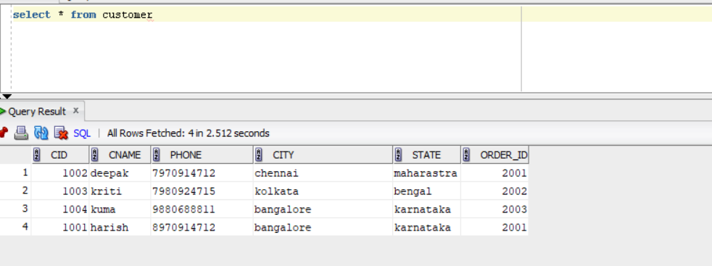

Customer Order Table:

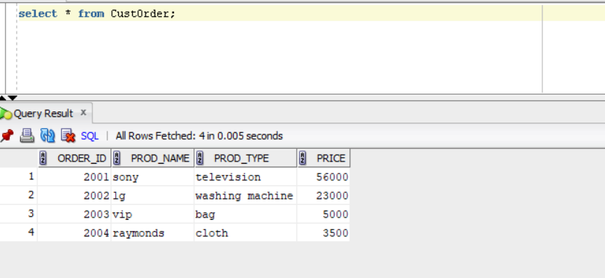

Below are the RESTFULL webservices create to fetch and manipulate the records of these tables.

1 : URI to fetch all the customers :

<http://localhost:8080/cust/>

2 : URI to fetch all the specific customer :

<http://localhost:8080/cust/1003> -🡪 customer id is 1003

3: URI to fetch all the customers and his Product details :

http://localhost:8080/cust/orderDetails

4: URI to update customer city :

[http://localhost:8080/cust/1003/mumbai {1003](http://localhost:8080/cust/1003/mumbai%20%7b1003) -🡪 for the cust id, updates city to Mumbai }